
ITE 3962 – Final Year Project
Project Proposal
An AI-Based Decision-Support System for
Order Batching and Picking Route Optimization

Submitted by:
E2529106
P. S. A. A. Seram

Bachelor of Information Technology (External Degree)
Faculty of Information Technology
University of Moratuwa

Declaration
I declare that this is my own research proposal, and this proposal does not incorporate, without acknowledgement, any material previously published or submitted for a degree or diploma in any other university or institute of higher learning, and to the best of my knowledge and belief, it does not contain any material previously published or written by another person except where acknowledgement is made in the text.

Signature: ..............................................
Date: ......................................................
P. S. A. A. Seram

I have read the proposal, and it is in accordance with the approved university proposal outline. I am willing to supervise the research work of the above candidate on the proposed area.

Signature of the supervisor: ..............................................
Date: ..................................................................................

Table of Contents
Declaration 2
Table of Contents 3
List Of Figures 4
List Of Tables 4
List Of Abbreviations 4
List Of Appendices 4
1. Introduction 5
2. Background & Motivation 6
2.1. Background of Warehouse Management 6
2.2. Order Fulfillment Process 7
2.3. Background of Order Picking 7
2.4. Challenges in the Existing Process 8
2.5. Need for Order Batching 8
2.6. Need for Intelligent Optimization 9
2.7. Role of Artificial Intelligence 9
2.8. Cart Capacity Management 9
2.9. Motivation for the Proposed Project 10
2.10. Expected Benefits 10
3. Literature Review 10
3.1. Research Gap 13
4. Problem In Brief 13
5. Aim & Objectives 14
5.1. Aim 14
5.2. Objectives 15
6. Proposed Solution 15
6.1. Order Management and Data Management 16
6.2. AI-Based Order Batching 17
6.3. Smart Picking Route and Sequence Optimization 17
6.4. Trolley/Cart Capacity and Intelligent Picking Plan 17
7. Conclusion 18
Appendix A: Plan of Action Time Line 19
References 19

List Of Figures
Figure 1: Existing Warehouse Order Fulfillment and Picking Process 7
Figure 2: Proposed AI-Powered Order Batching and Smart Picking Optimization Workflow 8
Figure 3: Proposed System Architecture and Data Flow 16

List Of Tables
Table 1: Existing Order Picking Problems 14
Table 2: Proposed System Technologies and Components 16

List Of Abbreviations
Abbreviation | Meaning
AI | Artificial Intelligence
API | Application Programming Interface
ASP.NET | Active Server Pages .NET
ML | Machine Learning
SQL | Structured Query Language
WMS | Warehouse Management System
UI | User Interface
UX | User Experience

List Of Appendices
Appendix | Title | Content
Appendix A | Plan of Action Time Line | Research/project planning
Appendix B | Project Development Time Line | Software development activities

Introduction
Online shopping and retail businesses are experiencing rapid growth to meet the increasing customer demand, with warehouses receiving more orders than ever within a short time frame. A warehouse is a crucial component in the accuracy of product fulfillment and fulfilling customer orders on time. But with many products and customer orders, the ability to manage warehouse activities efficiently starts decreasing.
Order picking is one of the core and most labour-intensive activities in the warehouse order fulfillment process. That mean is identifying products in the storage sites, gathering the necessary amounts and readying them to ship. Within a classical picking procedure, customer orders are frequently picked one by one. If multiple orders have identical or similar products, the same storage location will be visited multiple times by warehouse employees. This can add to the overall walking distance, picking duration, labour allocation rate and chance of picking mistakes.
The inefficiencies that arise become compounded challenges, which is why order batching can mitigate this through the grouping of suitable customer orders and processing them together. It is not easy to create effective batches manually, especially when working with a lot of orders.An appropriate batch should take into account a range of factors such as the nature of products in the orders (similarity), product quantities, weight, volume and even storage locations of products and trolley/cart capacity used by warehouse staff. Also, the sequence in which products are picked from different storage locations can have a high impact on picking distance and time.
For this reason, this project aims to provide an AI Tool of Order Batching and Smart Picking Optimization System for a one-warehouse. The described system will act on customer orders, group similar with respect to order fulfillment in batches based on feasible trolley limits and determine optimal pick sequence according to stock location. The proposed system will use React for frontend and ASP. NET Core Web API for our backend, and as a data layer we would use Microsoft SQL Server. It then performs similarity analysis to make smart order-batching and picking decisions.
So this system is a helpful assistant for supporting warehouse employees and not replacing them. This method will be evaluated based on the comparison of proposed one with conventional single-order picking. This evaluation will measure KPI’s such as total picking distance for the storage, time taken at each of these pick types, repeat visits to base locations and trolley-capacity utilization. This project will explore the potential of improving warehouse order fulfillment efficiency using intelligent order batching and picking optimization.

Background & Motivation
Storage and preparation of the items in relation to the customers' orders is a function of warehouses. When there is an overwhelming number of orders, then the staff has to go back to the same spots repeatedly because different orders have the same products. This increases the amount of work and distance covered by the staff while doing picking. Thus, another approach is needed for handling Order Picking.
Thus, a new and better methodology is required for the effective management of the Order Picking process. The motivation behind this project is to apply the concept of Artificial Intelligence (AI), Order Batching, and Order Picking Optimization to combine the like orders and make the Picking process more efficient by taking into account the location of the warehouse and the capacity of the Picking Cart.

Background of Warehouse Management
In the current business world, most businesses make use of warehouses in storing, managing, and distributing their products. The activities carried out in a warehouse involve receiving, inspecting, storing, inventory management, picking, packaging, and shipping of products in accordance with customer orders.

Order Fulfillment Process
The order fulfillment process is that activity which begins when an order for some goods is placed by the customer and ends with the delivery of the required items to him/her. Generally, the following activities are included in this process: Order processing, Quality Check, Order picking, packing and shipping. In order fulfillment process, the customer orders accurate goods in accurate quantity and at the right time.
Efficiency in this process will greatly impact how long it will take to complete the orders. In order to handle this efficiently especially as the number of orders increases, it is important to make improvements to the Order Fulfillment process. This is especially true considering the fact that employees need to travel to other places in the warehouse to pick up the items.
Moreover, in cases where orders have the same items, individual order picking will lead to repetitive travel to the same location in the warehouse. It will decrease the efficiency of order picking. Consequently, efficiency in warehouse operations can be achieved through grouping of orders having similar items and picking them simultaneously.
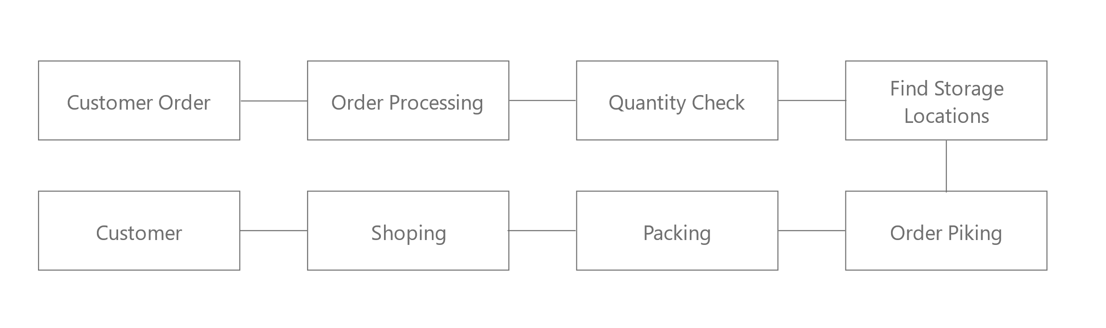
Figure 1: Existing Warehouse Order Fulfillment and Picking Process

Background of Order Picking
Order picking is one of the most important activities in the warehouse order fulfillment process. It involves locating and collecting the products required for customer orders from their respective storage locations [1].
As far as the traditional approach to picking is concerned, in this approach, it may be necessary for the workers to traverse different sections of the warehouse in order to pick the goods. An increase in orders also leads to the increase in the amount of time spent on picking goods because of additional movement. In the cases when several orders contain the same goods, the workers will have to visit the same section several times.
It will result in the waste of precious time from the part of workers as well as will contribute to the increase in order processing time. It becomes especially relevant when several orders arrive simultaneously, which is why it is important to cluster orders during the picking process.

Challenges in the Existing Process
If orders come in great numbers at one time, there may be various issues that will arise because of the traditional order picking approach. The primary issue is that all these orders will have identical goods. When orders are treated individually, an individual may need to make trips to the storage area again and again.
For instance, if there are 100 orders and most of them have identical goods, the individual may need to return to the same storage point each time to collect the goods.

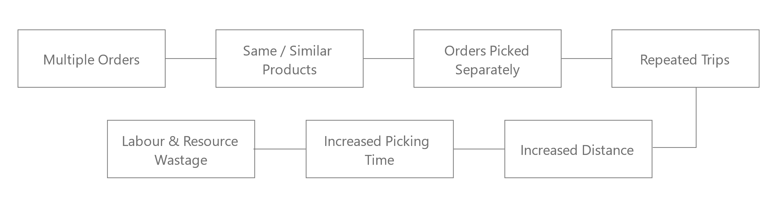
Figure 2: Proposed AI-Powered Order Batching and Smart Picking Optimization Workflow

Need for Order Batching
Order batching is a method of grouping multiple customer orders into suitable batches to improve the efficiency of the order picking process. When several orders contain the same or similar products, they can be planned and picked together instead of being processed separately [2].
For instance, if more than one order requires the same goods, then the system will recognize the similarities and form the right batches. This will allow the employee to get the required items all together without having to keep returning to the same spot.

Need for Intelligent Optimization
When the volume of orders and items increases, it becomes difficult to make the decision of what could be the best picking stacks and the picking order. In this context, the intelligent system analyzes the data of orders and items and makes the best decision for picking.
The optimization techniques will help to determine the right picking stacks and prevent unnecessary traveling within the warehouse.

Role of Artificial Intelligence
In addition, the use of artificial intelligence can be considered when analyzing orders and discovering patterns that cannot be identified by humans. In this study, AI will provide order similarity analysis and will help to develop a strategy for bundling orders.
The integration of AI-powered decision-making with optimization techniques makes the order picking process even more efficient. Not only does it become automated, but also becomes smarter.

Cart Capacity Management
One other very important factor to consider is the capacity of the cart used in order picking. The order should have no more items than the capacity of the cart that would carry those items. Cart capacity is thus an important factor in designing the order.
With the factor of cart capacity considered, the system would make it easier to design picking orders.

Motivation for the Proposed Project
The overall goal of the project is to enhance the efficiency of order fulfillment in the warehouse by eliminating unnecessary movement and repetition in the picking process. The project will provide an intelligent solution to the order consolidation and picking activity management for the whole warehouse.
The software enables warehouse employees to complete order fulfillment tasks more efficiently using intelligent order consolidation, intelligent picking, cart capacity assessment, and analytics.

Expected Benefits
The objective of the new methodological approach is to minimize unnecessary movement in the warehouse, avoid double handling of items, make the employees more productive, and ensure that the order processing time is minimized. This approach may also be beneficial for managing large quantities of orders.

Literature Review
Warehouse management consists of several important activities, including receiving, storage, inventory management, order picking, and shipping. Gu, Goetschalckx, and McGinnis [1] presented a comprehensive review of warehouse operations and classified warehouse planning problems according to these major functions. Their study highlights the importance of decision-support models and solution methods for improving warehouse operations. Among these activities, order picking is particularly important because it directly affects the time and resources required to fulfil customer orders.
Order picking involves retrieving products from their storage locations according to customer order requirements. de Koster, Le-Duc, and Roodbergen [2]identified order picking as one of the most labour-intensive and costly activities in warehouse operations. Their literature review examined several important decision areas, including warehouse layout, storage assignment, routing, order batching, and zoning. The study indicates that effective design and control of the picking process are essential for achieving efficient warehouse operations. It also highlights that combinations of different decision areas provide opportunities for further research.
One of the important approaches for improving order-picking efficiency is order batching. Order batching involves grouping several customer orders into suitable batches before the picking process begins. Henn, Koch, and Wäscher [3] reviewed different solution approaches for order batching and highlighted its importance in reducing picking time and improving the efficiency of manual order-picking systems. Their study also distinguishes between static and dynamic order batching approaches. This indicates that grouping suitable orders before picking can reduce unnecessary movement and improve the overall efficiency of the picking process.
More recent research has further examined order batching as an optimization problem. Pardo, Gil-Borrás, Alonso-Ayuso, and Duarte [4] presented a taxonomy and literature review of order batching problems. Their study considers order batching as a family of optimization problems in which customer orders are grouped into batches before picking. The review identifies different strategic, tactical, and operational decisions and examines related activities such as batching, routing, sequencing, waiting, and assignment. The study also identifies open issues and future research directions in order batching. This provides a strong research foundation for developing an intelligent system that combines order grouping with picking decisions.

Order batching alone, however, may not provide an optimal picking solution. After customer orders have been grouped, an appropriate picking route and sequence must be determined. de Koster et al. [5] identify routing and order batching as important decision areas in warehouse order-picking systems. Similarly, Pardo et al. [3] discuss the relationship between batching, routing, and sequencing in order-picking optimization. An inefficient picking sequence can cause unnecessary movement between storage locations, increasing the total distance travelled by warehouse employees and the time required to complete the picking process.
Furthermore, the increasing availability of warehouse data also makes it possible to implement artificial intelligence and machine learning approaches into decision making regarding warehouses. Order data may have information about goods, number of goods, and combinations of goods. Such data can be analyzed in order to find similarities and patterns. Based on such patterns, an intelligent system is able to provide assistance in finding out appropriate order groups. Nevertheless, the majority of literature that has been discussed above concentrates on optimization and decision making strategies for order picking and order batching.
Another consideration of practical nature is on the handling capacity of the units themselves. When multiple orders are put in one batch then the order quantity, weight and volume must also be within the loading threshold of available trolley or cart. Hence, a sound picking plan is to take into account order similarity and physical constraints. The proposed research combines product quantity, weight, size, storage location and trolley/cart capacities into order batching and picking optimization.
The reviewed literature indicates that there has been significant research on the optimization of important warehouse problems such as order picking, order batching, routing and sequencing [1]–[4]. On the other hand, such concepts can be integrated with an AI-based decision-support mechanism while leveraging order similarity alongside exact cart-capacity constraints in a single-warehouse environment. This research thus proposes an AI-based Order Batching and Smart Picking Optimization System that examines customer orders to form meaningful and effective batches, identify picking sequences based on the optimized distribution of order batching while taking trolley/cart capacity into consideration.
This system has been designed in order to support, not replace warehouse workers. Measurable performance indicators such as picking distance, re-visits to storage locations & picking time will be analyzed in this research to assess the effectiveness of the proposed approach with respect to conventional picking method. These evaluation measures align with the goals laid out in the proposed project.
On the whole, the literature reviewed indicates that operations of order group optimisation, minimisation of unnecessary travel and pick route improves efficiency for warehouse order-fulfilment. The research proposed in this paper leverages the established concepts of AI based order similarity analysis, order batching, smart picking-route optimization, and trolley/cart capacity management to develop a single-warehouse decision-support system.

  - Research Gap
The literature reviewed in this chapter demonstrates that warehouse order picking efficiency can be improved through order batching, routing, sequencing, and optimization techniques. Previous studies have also examined the use of data-driven and artificial intelligence approaches to support warehouse decision-making.
However, the reviewed studies do not fully address the integration of order similarity, product quantity, product weight, product volume, storage locations, and trolley or cart capacity within a practical decision-support system for a single warehouse. In many existing approaches, these factors are considered separately or focus mainly on one objective, such as reducing distance or minimizing picking time.
Therefore, there is a need for an integrated and practical system that can identify similar customer orders, create feasible batches according to trolley or cart capacity, and generate an efficient picking sequence based on product storage locations. The proposed AI-Powered Order Batching and Smart Picking Optimization System aims to address this gap by combining order batching, cart-capacity management, and picking-route optimization in a single-warehouse environment. The effectiveness of the proposed system will be evaluated by comparing it with the conventional individual-order picking method using picking distance, picking time, repeated visits to storage locations, and trolley or cart utilization.

Problem In Brief
Order picking has become a very difficult task for any warehouse today where one needs to process many orders at once. When multiple customers place orders that consist of the same product or products that look alike, picking these orders individually could result in making more than one trip by the warehouse worker to the same location in the warehouse. For instance, if one processes 100 orders at once and some of them need the same product, then one might make multiple trips to the same place.
The effect of this will be to lengthen the route and take more time for the employee to collect orders. In cases of high volume, orders with similar orders will have to be transported several times to the same storage place because of improper grouping of orders. Also, it is not easy to make a plan of collecting orders taking into consideration the size of the trolley and the storage places. Then I could identify below problems.
- Repeated Trips to the Same Storage Location
- Inefficient Order Grouping
- Increased Picking Distance
- Increased Picking Time
- Inefficient Trolley/Cart Utilization
- Difficulty Considering Product Weight and Size
- Difficulty in Selecting an Optimal Picking Route
- Unnecessary Use of Employee Labor
- Difficulty Handling High Volumes of Orders
- Lack of Intelligent Data-Based Picking Decisions

No. | Main Problem
1 | Repeated Trips and Increased Picking Distance
2 | Inefficient Order Grouping and Increased Picking Time
3 | Inefficient Cart and Product Capacity Management
4 | Difficulty in Optimal Route Selection and Intelligent Decision-Making
Table 1: Existing Order Picking Problems

Aim & Objectives

Aim
To develop and evaluate an AI-based decision-support system that groups suitable customer orders into feasible batches and generates efficient picking sequences for a single warehouse while considering product information, storage locations, and trolley capacity.

Objectives
The objectives of this project are:
- Understand the existing process of warehouse order picking and identify the key problems that negatively affect the efficiency of goods picking.
- Finding out objects that have commonality in many orders and examining the feasibility of incorporating them in one go.
- Develop a suitable group order process taking into account the capacity of the cart.
- Optimizing an intelligent picking optimization system to find out the most efficient picking order between various storage locations.
- Development of a system to handle order management, order batching, and intelligent order picking.
- In order to analyze the efficiency of the system that was suggested, comparisons were carried out for both conventional and the suggested systems on the basis of picking distances, re-visits to the same location, and picking time.

Proposed Solution
The research aims at developing an AI-powered Order Batching and Smart Picking Optimization System. The system will be designed for a single warehouse where the aim will be to handle customers’ orders received simultaneously by grouping those orders which need similar items and creating better picking sequences for the employees of the warehouse.
It is intended to employ ASP.NET Core Web API as the backend platform, React as the front end web interface, and Microsoft SQL Server as the database in order to design the system. Machine learning / artificial intelligence will be applied in order to group orders based on similarities and optimization techniques in order to optimize picking paths and routes.
Component | Technology / Method
Frontend | React + vite
Backend | ASP.NET Core Web API
Database | Microsoft SQL Server
Order Batching | Artificial Intelligence / Machine Learning
Picking Optimization | Optimization Algorithms
Data Management | Customer Orders, Products, Quantity, Location, Weight and Size
Cart Management | Cart Capacity
Table 2: Proposed System Technologies and Components

Order Management and Data Management
Firstly, the system organizes the requirements data including customer orders, products, quantity, location of storing products, weight of products, size of products, and capacity of the trolley/cart.
The database is Microsoft SQL Server database and the relationship between the database and the business logic of the system is handled by ASP.NET Core Web API. The React front-end enables the administrator or store employee to choose the required order and data.
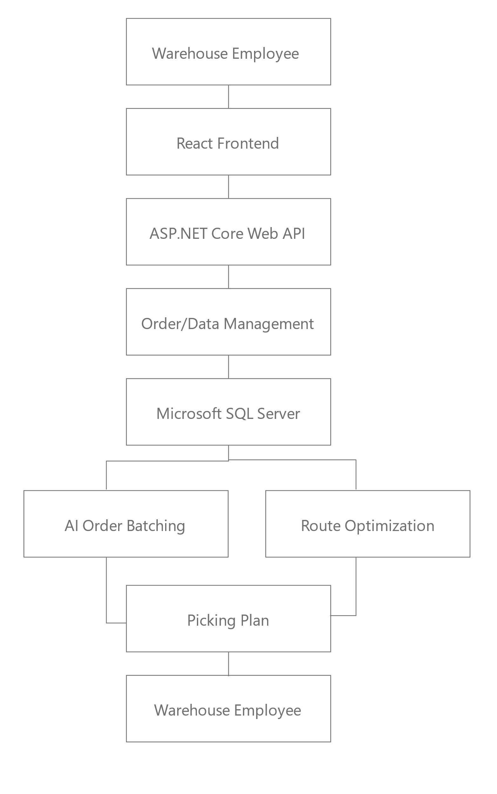
Figure 3: Proposed System Architecture and Data Flow

AI-Based Order Batching
If a large volume of customer orders are received simultaneously, rather than processing them on an individual basis, an AI-powered strategy will be adopted to group similar products in orders and form suitable batches.
The AI/ML system will process similarities among products and orders and group orders where the similar items can be processed together. The key objective here is to cut down the number of visits made by employees to the same location in the storehouse.
The system looks at customer orders and checks things like the product details along with size weight quantity and where everything is stored. It finds orders that have a lot in common based on those points. Then an AI or machine learning approach gets used to put them into batches. I think that part is meant to make the grouping smarter but it is not always clear how many batches end up being made.
Batches do not just get sent ahead right away. There is a check first to make sure they fit within the limits of the trolleys or carts before anything moves to picking. This seems like a necessary step otherwise things could get overloaded. Maybe the capacity rules are stricter than they appear at first. The whole flow depends on order data staying accurate though.

Smart Picking Route and Sequence Optimization
Order batches will be created after which the order of picking will be defined depending on the storage location where the products for that particular batch are stored.
Here, an optimal route algorithm will be employed in order to define the most effective way of moving from one storage location to another. This will help to cut down wastage of time due to unnecessary walkovers.
This system will inform the warehouse picker of the products to pick, their quantities, and the storage locations to collect them from.

Trolley/Cart Capacity and Intelligent Picking Plan
The carrying capacity of the trolley/cart is another important factor to consider while designing order batches. Data on the quantity, weight, and size of products will be utilized to determine whether the chosen orders can fit the capacity of the trolley/cart.
With the combination of all these data and order batching & picking optimization process, the system will be able to design a picking strategy that is not only feasible from the standpoint of trolley/cart carrying capacity but also easy to implement by a warehouse worker.

Conclusion
Order picking is one of the crucial tasks involved in the warehouse order fulfillment process, and the performance of order picking becomes less efficient when there is a need to process many customer orders simultaneously. Picking orders for those customers who require similar items separately creates challenges like multiple visits to the same warehouse location, higher picking distance, more picking time, inefficient utilization of the Trolley/Cart and labor wastage of the employees.
The development of the AI-Powered Order Batching and Smart Picking Optimization System is the possible solution to the abovementioned challenges. It will be designed for a single warehouse only, and will evaluate customer orders along with product details in order to find out customer orders that contain similar products and help create suitable Order Batches.
These technologies that will be used for developing the system are ASP.NET Core Web API, React and Microsoft SQL Server, while for Order Batching and Picking Optimization Artificial Intelligence / Machine Learning techniques and Optimization Algorithms will be utilized. The purpose of the development is not to substitute employees working in the warehouse by means of the system, but to offer them intelligent assistance in decision-making on picking orders.
Finally, the performance of the proposed system will be assessed on the basis of indicators such as Picking Distance, Repeated Visits to Storage Location and Picking Time in comparison with the traditional method of picking. This research will allow finding out if there is any possibility to increase the efficiency of order fulfillment in warehouses thanks to the implementation of AI-based Order Batching and Smart Picking Optimization.

Appendix A: Plan of Action Time Line

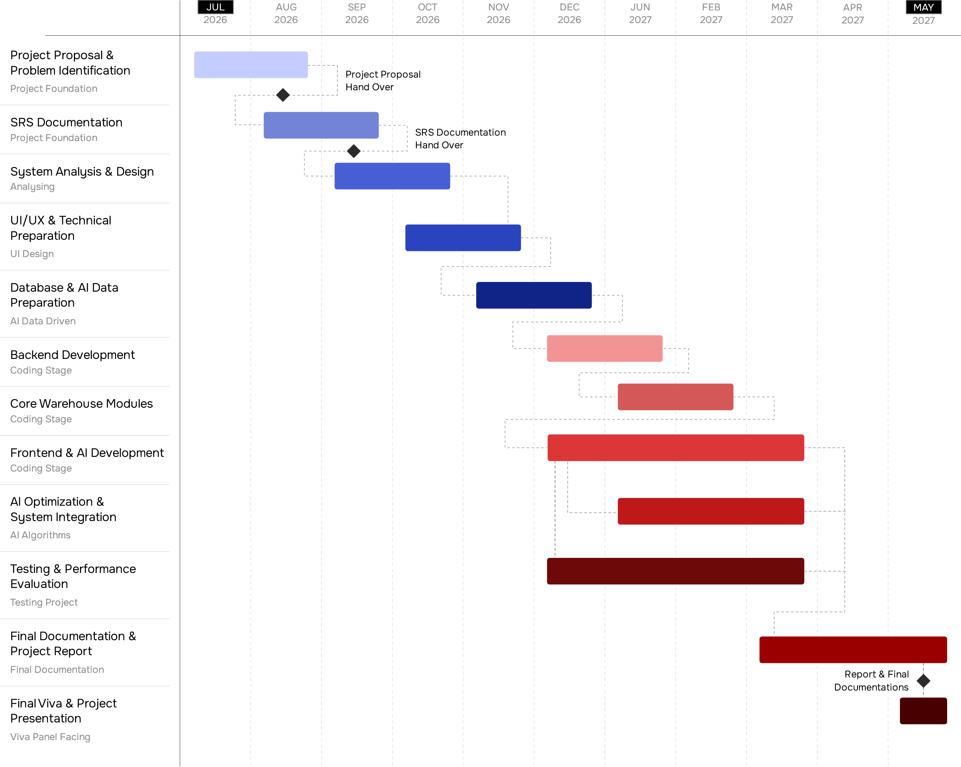

References

[1] | J. Gu, M. Goetschalckx and K. S. McGinnis, “Research on warehouse operation: A comprehensive review,” European Journal of Operational Research, vol. 177, no. 1, p. 1–21, 2007.
[2] | R. de Koster, T. Le-Duc and K. J. Roodbergen, “Design and control of warehouse order picking: A literature review,” European Journal of Operational Research, vol. 182, no. 2, p. 481–501, 2007.
[3] | S. Henn, S. Koch and G. Wäscher, “Order batching in order picking warehouses: A survey of solution approaches,” 2011.
[4] | E. G. Pardo, S. Gil-Borrás, A. Alonso-Ayuso and A. Duarte, “Order batching problems: Taxonomy and literature review,” European Journal of Operational Research, vol. 313, no. 1, p. 1–24, 2024.
[5] | R. F. de Assis, A. F. Faria, V. Thomasset-Laperrière, L. A. Santa-Eulalia, M. Ouhimmou and W. d. P. Ferreira, “Machine Learning in Warehouse Management: A Survey,” Procedia Computer Science, vol. 232, p. 2790–2799, 2024.
[6] | K. J. Roodbergen and R. de Koster, “Routing methods for warehouses with multiple cross aisles,” International Journal of Production Research, vol. 39, no. 9, pp. 1865-1883, 2001.
[7] | W. H. Hausman, L. B. Schwarz and S. C. Graves, “Optimal storage assignment in automatic warehousing systems,” Management Science, vol. 22, no. 6, p. 629–638, 1976.

